

Aror University of Art, Architecture Design & Heritage Sukkur
Department of AI-Multimedia and Gaming

Team Members: Tahir Mahmood and Ghufran
Roll No: ARI-F23-0050 and ARI-F23-0021
Section: A
Subject: Programming for AI
Department: Artificial Intelligence
Teacher: Sir Abdul Haseeb Sheikh
Final Project : Skin Cancer Detection

1. Objectives
The main objectives of this project are:
- To detect different types of skin cancer using deep learning.
- To provide a simple, attractive GUI for users to upload skin lesion images.
- To predict whether the uploaded image contains cancerous tissue.
- To display user-friendly, accurate results with clear confidence scores.
- To ensure the system is accessible and can help raise early awareness of skin cancer risks.

2. Introduction
Skin cancer is one of the most common types of cancer, and early detection is critical for effective treatment. Dermatologists often rely on visual inspection and biopsies, which can be time-consuming and costly. This project uses AI and computer vision to help identify possible cancerous lesions using a trained model and a user-friendly Python GUI.
The application is built with:
- Tkinter for GUI
- TensorFlow for prediction using a trained CNN model (keras_model.h5)
- PIL and NumPy for image processing
- A pre-defined set of skin disease labels

3. Abstraction
The system abstracts the technical complexity behind a simple interface. The user just needs to:
- Open the app.
- Upload a skin image.
- Click a button to check for cancer.
- See the result (cancer type or non-cancer) along with confidence level.
The app handles:
- Image validation (checking brightness/clarity).
- Preprocessing the image (resize, normalization).
- Running it through a trained deep learning model.
- Displaying a clear, understandable result.

4. Methodology
Here is how the system works step by step:

4.1 Image Upload
- User uploads a .jpg, .jpeg, or .png file.
- The uploaded image is resized and displayed on the GUI.

4.2 Validation
- The image is checked to ensure it is a valid skin lesion image by analyzing pixel brightness (mean value).

4.3 Preprocessing
- The image is resized to 224x224 pixels.
- It is normalized (pixel values between 0 and 1).
- The processed image is reshaped and passed to the model.

4.4 Prediction
- The model returns prediction probabilities for each class.
- The highest probability is selected using argmax.
- Confidence score is calculated.
- If the predicted class index belongs to predefined cancerous class indices ([0, 1, 3, 7]), it warns the user.

4.5 Result Display
- If confidence is below 70%, a warning is shown.
- Otherwise, result is shown with class name and confidence score.
- Messages are color-coded:
  - 🔴 for cancer
  - 🟢 for no cancer
  - ⚠️ for unclear results

5. Model Name
- Model Used: keras_model.h5
- Framework: TensorFlow / Keras
- Input Size: 224x224 RGB image
- Labels File: labels.txt (contains class names such as melanoma, benign keratosis, etc.)
- Cancer Class Indices: [0, 1, 3, 7] (based on label order in the file)
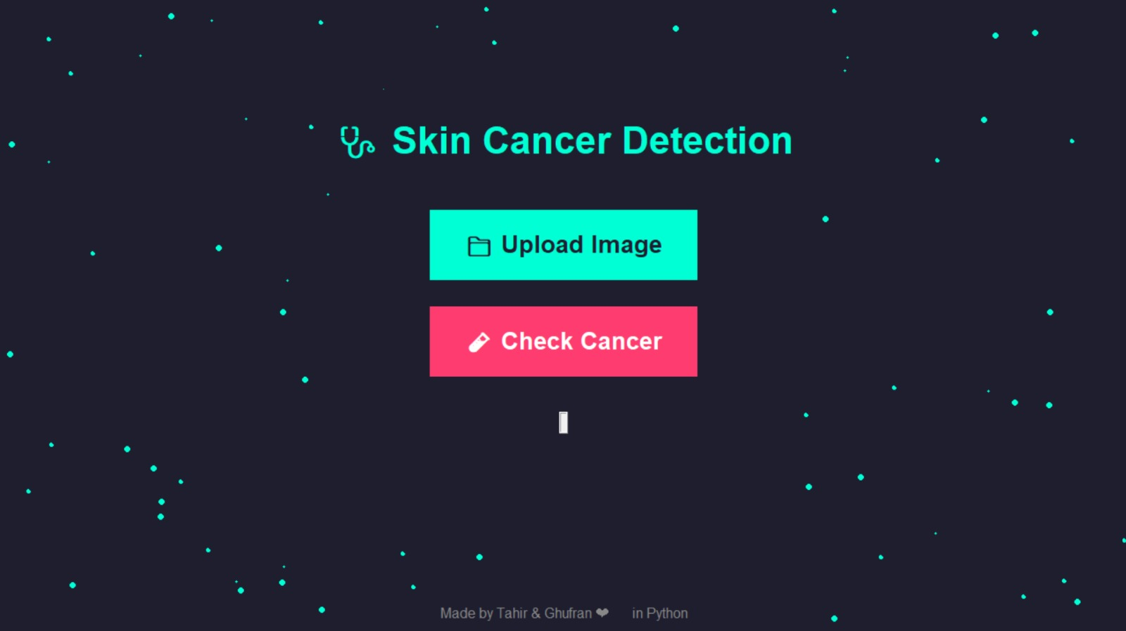

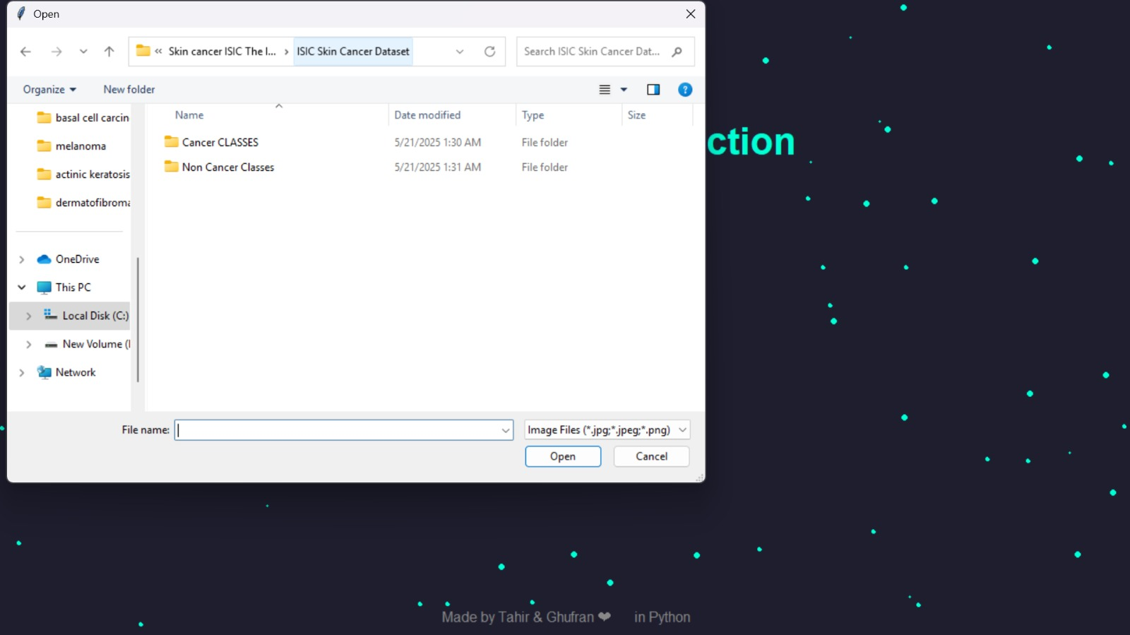

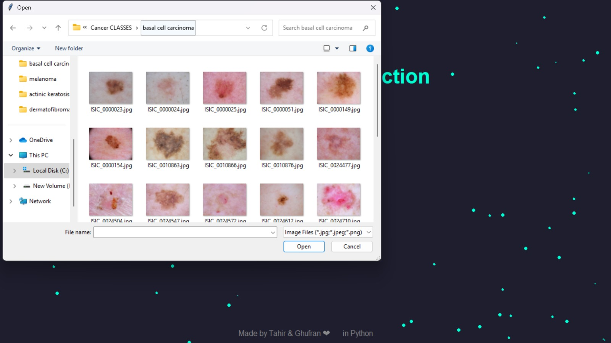

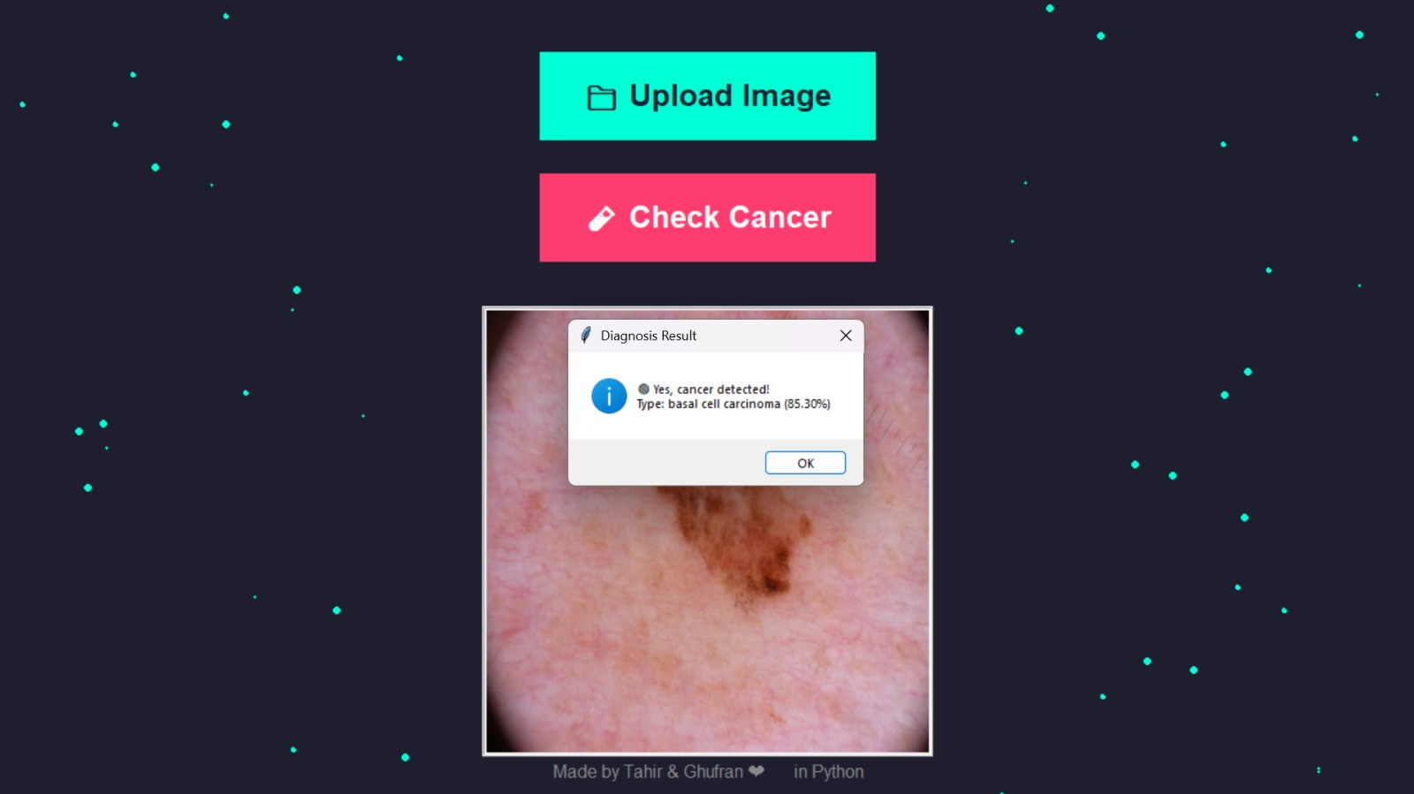

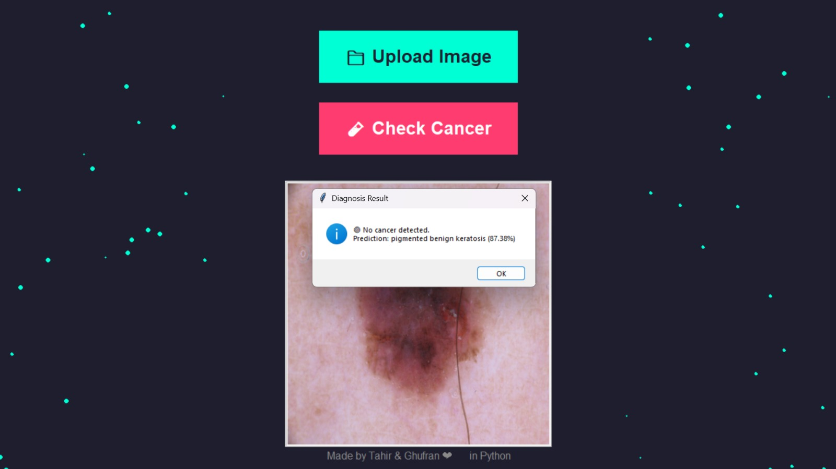

6. Conclusion
This Skin Cancer Detection System is a simple, useful, and educational project that demonstrates the power of deep learning in healthcare. By integrating a trained model with an interactive GUI, it allows users to easily test skin lesion images and get meaningful diagnostic information. Although it is not a replacement for a professional diagnosis, it can assist in early awareness and encourage timely medical consultation.
Future improvements may include:
- Mobile app integration.
- Real-time camera input.
- Larger dataset training for better accuracy.
- More detailed output with medical advice or links.

